What it’s all about!!!

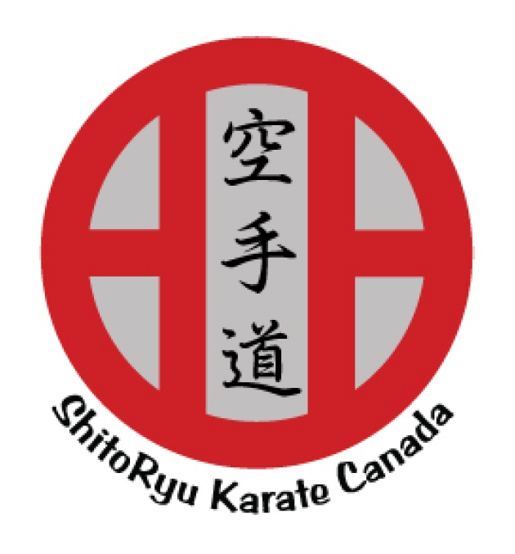

Karate is an ancient form of self-defense developed on a small island off the southern coast of Japan in the China Sea known as Okinawa. In 1509, in an attempt to quell insurrection and protect his monarchy, the Okinawan King, Shoshin, banned the stockpiling of weapons and ruled that all the feudal lords live within the main castle boundaries. Over the next several centuries Karate or To-di, as it was known in old times flourished. At the turn of the 20th century, with the change of the political climate and the advent of modern weaponry, Karate underwent a radical transformation. With the intention of developing the youth of the Nation physically and help prepare its young people for potential military service. Karate was introduced to the school system in the Okinawan capital of Shuri. In the 1920’s Karate was introduced to mainland Japan and taught diligently in the universities in and around Tokyo. After World War II, the occupying allied troops took up this “interesting” form of self-defense and spread it to the world upon returning home from their tour of duty. Today there are an estimated 40 million people practicing the different forms of Karate all over the globe.

History

The Windsor Karate Club
The Windsor Karate Club was founded by David Griffin in September of 1981 and operated out of the old Windsor Regional High School on Wentworth Road as part of the continuing education program. As the club grew, the program began to expand.
In July of 1988, David and Theresa Griffin purchased the old Mapleton Hall in Three Mile plains. At the time, the building was unoccupied and had not been used for several years. The building had been neglected and its condition had deteriorated significantly. There were several places where the roof had collapsed, and portions of the structure had begun to show the effects of prolonged exposure to the elements. In addition, the foundation was cracked in several places, and it was feared that if not repaired immediately, the building might collapse. The students and parents worked tirelessly for the remainder of the summer and well into the fall repairing and bringing the old building back to life. Classes resumed in September of 1988 however there was still much work to be done. With the most pressing and immediate projects completed, work and renovation continued over the next few years with items being tackled on an as-needed basis, when the money was available.
The style of Karate practised at the Windsor Karate Club is Shito-Ryu which has a rich and colourful history as well as an interesting and complex curriculum. The style originally practised at the club was Chito-ryu which although phonetically similar to Shito-Ryu are vastly different. Chito-Ryu was practised at the Windsor Karate Club from it's founding to about 1997 when Sensei David Akutagawa, our former Chief Instructor for Canada, left the Canadian Chito-Kai Association and formed Renshikan Karate-do International. The changing of styles was slow and difficult and it took about 5 years fully assimilate the new methodology and curriculum. In October of 2008 Sensei Akutagawa passed away suddenly and tragically and the technical responsibilities of Renshikan fell to its senior students.
In 2013 The Windsor Karate Club became the Head Dojo and training centre for Shito-Ryu Karate Nova Scotia as members of Shito-Ryu Karate Canada. Shito-Ryu Karate Canada was founded by Sensei Allen Tanzadeh of Toronto who is also the Technical director.
The Windsor Karate Club is the oldest Martial Arts School in Hants County. David Griffin retired as head instructor in January of 2022 and left the club to a dedicated group of his senior students. All instructors are well trained and experienced black belts. Many of our students have competed Provincially, Regionally and Nationally and some have gone on to represent Canada at international events.

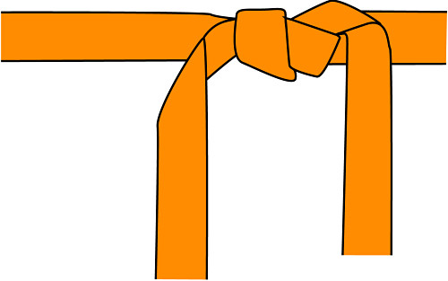

The 20 Precepts
- Karate-do begins with courtesy and ends with rei.
- There is no first strike in karate.
- Karate is an aid to justice.
- First know yourself before attempting to know others.
- Spirit first, technique second.
- Always be ready to release your mind.
- Accidents arise from negligence.
- Do not think that karate training is only in the dojo.
- It will take your entire life to learn karate, there is no limit.
- Put your everyday living into karate and you will find "Myo" (subtle secrets).
- Karate is like boiling water, if you do not heat it constantly, it will cool.
- Do not think that you have to win, think rather that you do not have to lose.
- Victory depends on your ability to distinguish vulnerable points from invulnerable ones.
- The out come of the battle depends on how you handle weakness and strength.
- Think of your opponent’s hands and feet as swords.
- When you leave home, think that you have numerous opponents waiting for you.
- Beginners must master low stance and posture; natural body positions are for the advanced.
- Practicing a Kata exactly is one thing, engaging in a real fight is another.
- Do not forget to correctly apply: strength and weakness of power, stretching and contraction of the body, and slowness and speed of techniques.
- Always think and devise ways to live the precepts of karate-do every day.
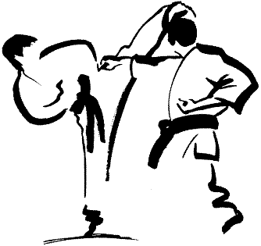

DOJO

DOJO: A place where you train your mind, body and technique by Budo.

At the dojo, you must behave with good manners and be moderate. You must always have pride in being a Karate-Ka and endeavor to express in your living the training of the mind and body, always being aware that living itself is a part of training.

Rules For Entering and Leaving the Dojo

- Greet Shomen with bow (front of dojo) (respect to Shomen).

- Greet those who are present in the dojo by saying “hello” acknowledging the instructor “Sensei” prior to the others.

- It is prohibited to enter the dojo with shoes.

- Senior members shall be kind, considerate and helpful to the junior members and through this effort will result a friendship based on the fact that we are all striving for the same goal.

- Newer members shall always show their utmost respect for the seniors, always greeting them first.

- Profanity will not be permitted to be used in the dojo.

- It is prohibited to smoke and chew gum in the dojo.

- Address the instructor by “Sensei”.

- Members shall respect the instructor who shall in turn strive to be an example in front of the students.

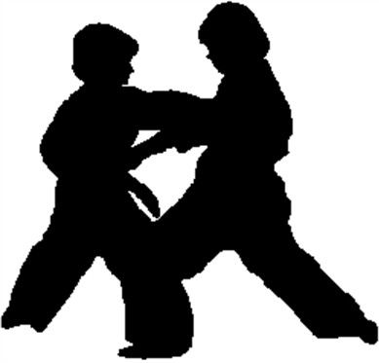

Rules for Karate-Kas

- Endeavour to develop yourself into a person of good character.

- Live a respectable life with honesty and dignity.

- Put all your energy and soul into everything you make or do.

- Practice politeness and understanding towards other people.

- Always maintain complete control over your temper and emotions.

- Priority of life- Be aware of priorities in life; Karate must be a secondary priority. (e.g. – Student- must put education first).

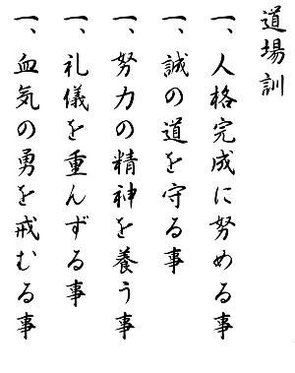
Dojo Kun(Moto)

Japanese

Hitotsu- Jinkaku kansei ni tsuto meru koto
Hitotsu- Makoto no michi o mamoru koto
Hitotsu- Doryoku no seishin o yashinau koto
Hitotsu- Rei gi o omonzuru koto
Hitotsu- Kekki no yu o imashimuru koto

English
One- Seek perfection of character.
One- Be faithful.
One- Endeavor to excel.
One- Respect others.
One- Refrain from violent behavior.

